Creating a Proposal - Audio

Selecting Round and Brief 1
Proposal Form - Open Round 3
Tell us about your idea 3
Developing your idea 4
Contributors 5
About your proposal 6
Diversity and Inclusion 7
Production Budget & Notifications 7
Save as draft 8
Additional Information 9
Review & Submit 11
Proposal Form - First stage of a two-step proposal 12
Overview of the process 12
Tell us about your idea 12
Contributors 13
About your proposal 14
Diversity and Inclusion 14
Production Budget & Notifications 15
Save as draft 16
Additional Information 17
Review & Submit 19
Proposal Form – Second stage of a two-step proposal 20
Knowing your proposal has progressed 20
Navigating to your proposal 20
Adding your Full Proposal 21
Adding Additional Information 22
Review & Submit 23
Internal Only - Submitting to Department 24
Internal Only – Reviewing and Submitting to Network 24

Selecting Round and Brief
Once you have logged into PiCoS, you will be presented with the dashboard.

To start creating your proposal select ‘Create new proposal’

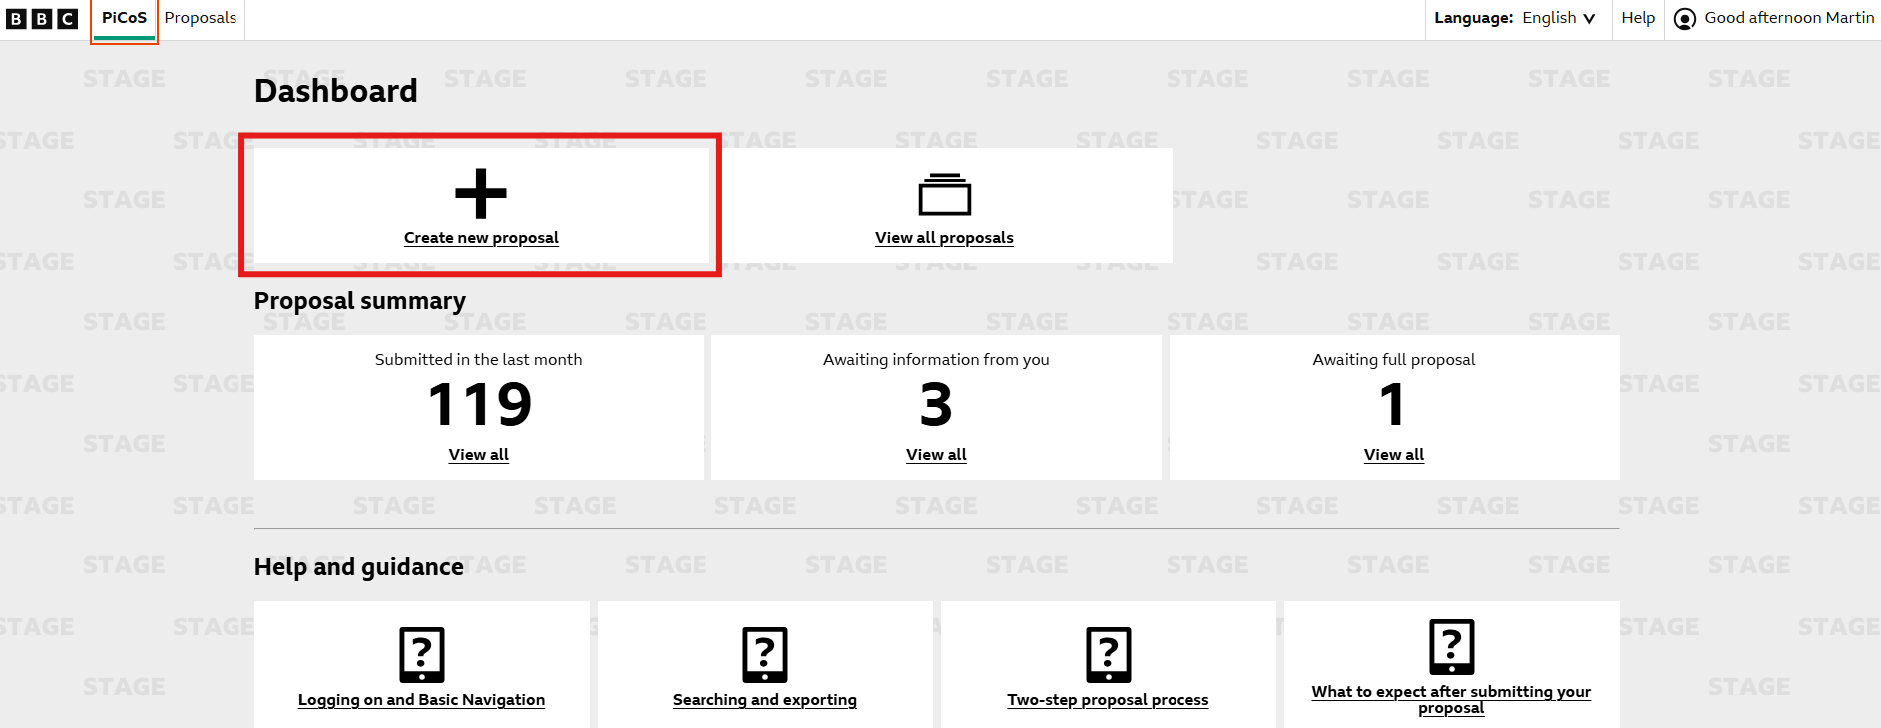

From here you can select the network you want to submit your proposal to.

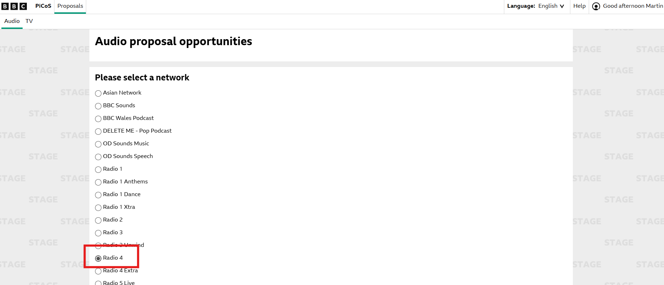

You will then be prompted to select the correct round you would like to pitch to. Once you have selected this round you can select ‘Next’

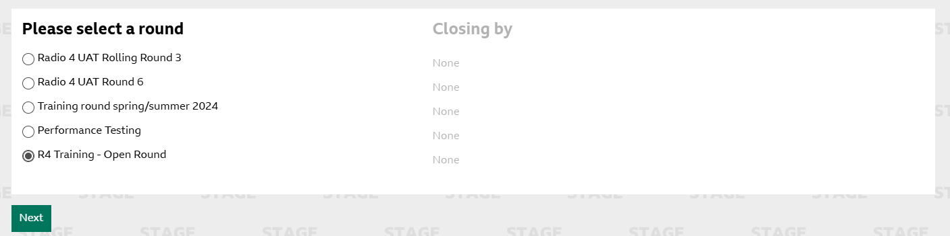

This will now take you to a page to select the brief you want to submit your idea to. To select the brief, you want to submit to click ‘Pitch’

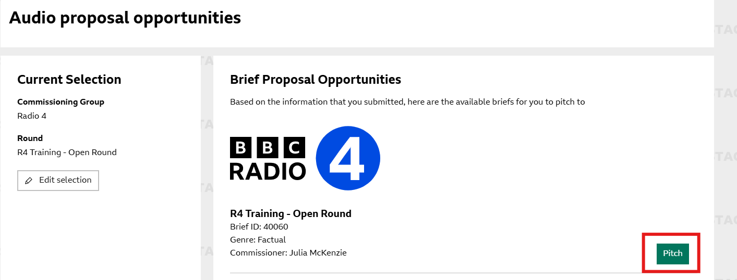

You will now be able to start creating your proposal.

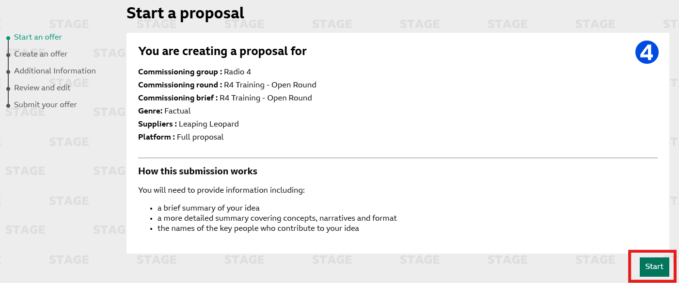

Please see the following sections depending on the style of round you are submitting to.

Proposal Form - Open Round

Tell us about your idea
In this section, you will need to add in your Proposal title and the short proposal. The word limit for your short proposal is maxed at 500 words. However, please ensure to refer to your commissioning brief to ensure the word count is not lower that the 500 limit that PiCoS allows.
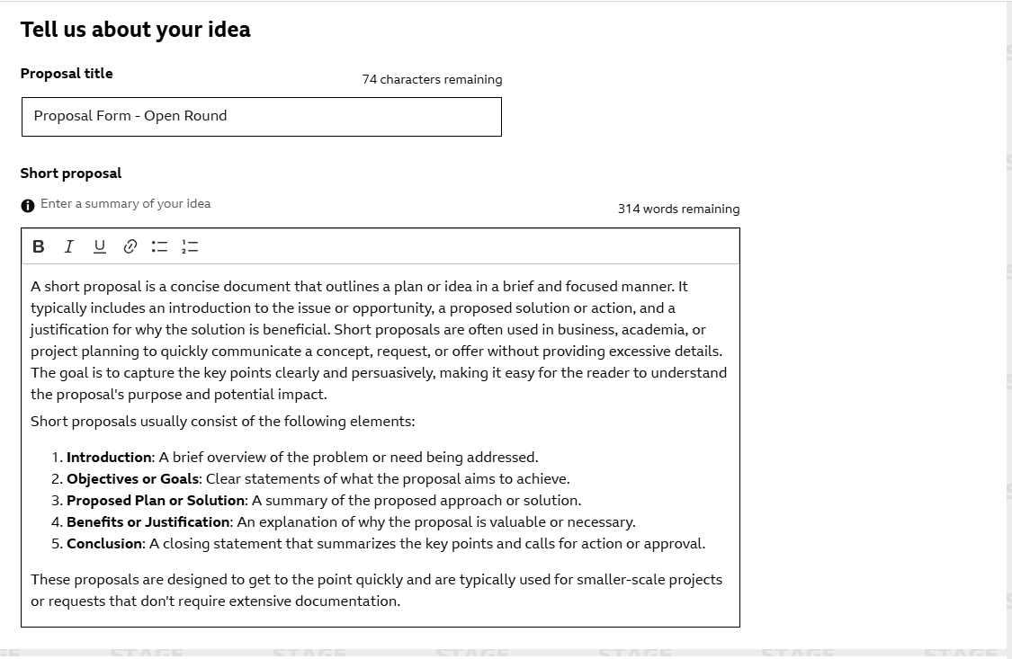

Developing your idea

In this section, please complete your full proposal. There is a 5000-word limit in this field with a selection of basic formatting options available.

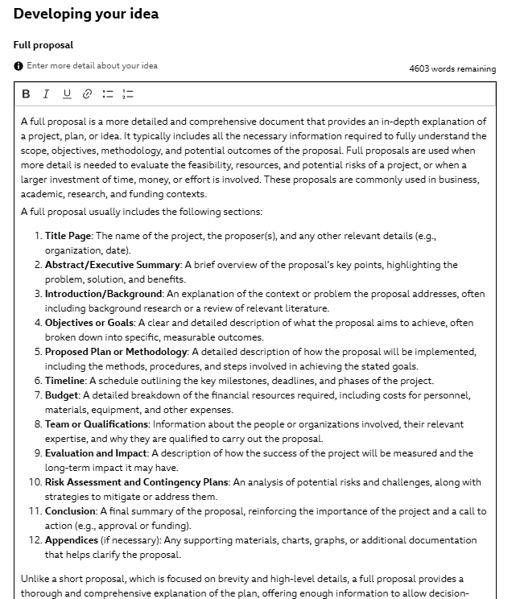

Contributors

In the next section, please add in the contributors of your programme. The only field that is mandatory is the ‘Producer’ field. All other contributor fields are optional.

You can add additional contributors of the same field by clicking the ‘Add more’ button to the right of the desired field.
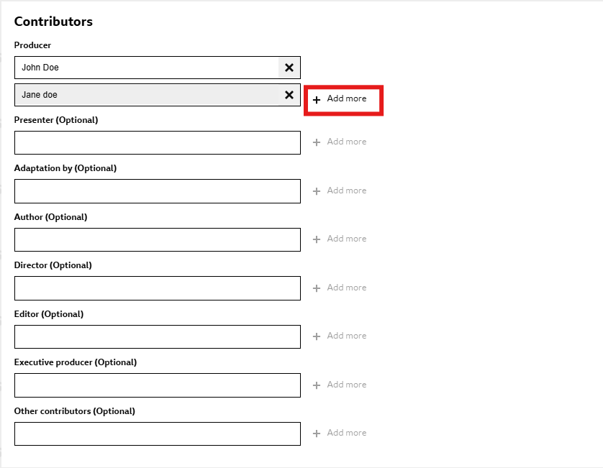

About your proposal

The below section is asking for specific information regarding your proposal. All the below fields are mandatory.

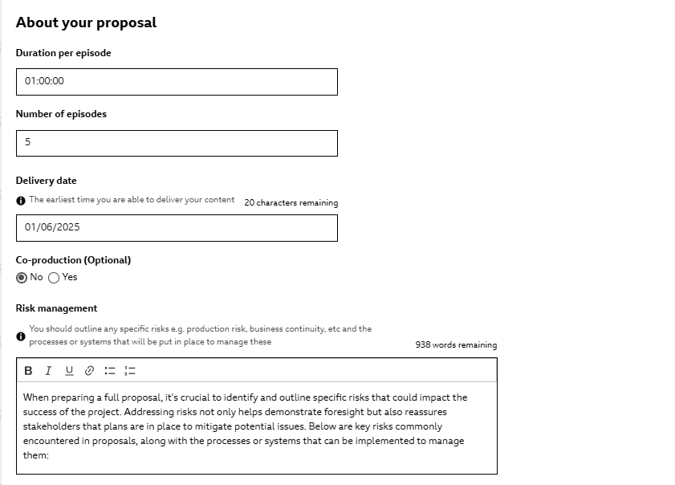

Diversity and Inclusion

The next section of your proposal form is all about the diversity and inclusion information. This is separated into three categories, Company Leadership, Production Leadership and Landmark Portrayal.

If you select ‘Yes’ to Landmark Portrayal you will be given a text field to explain for your Proposal meets these criteria. This field has a 250-word count limit.

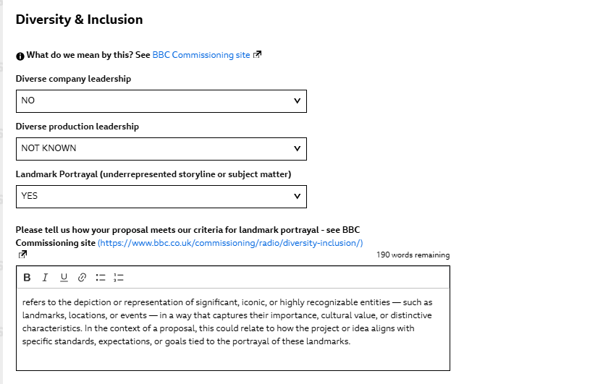

Production Budget & Notifications

In the Production Budget section of the form, you will see the guide price that has been outlined by the commissioning team. You can then enter your proposed price per episode. This field is optional and can be added by the commissioning team later.

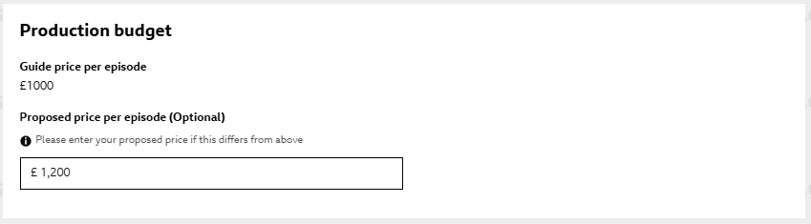

In the notification section, this shows you who will receive the notifications for your proposal. This is defaulted to send notifications to the creator of the proposal. You add additional people if you wish to notify others regarding this proposal, to do this, add their email address in the box provided.
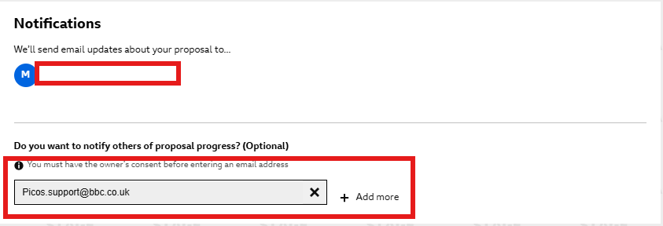

You will then need to tick the Terms and Conditions before proceeding to ‘Additional Information’

Save as draft

Once you have completed the first page of your proposal, you can save this and come back to it later. At the bottom of the page, you will see a black button ‘Save as draft’

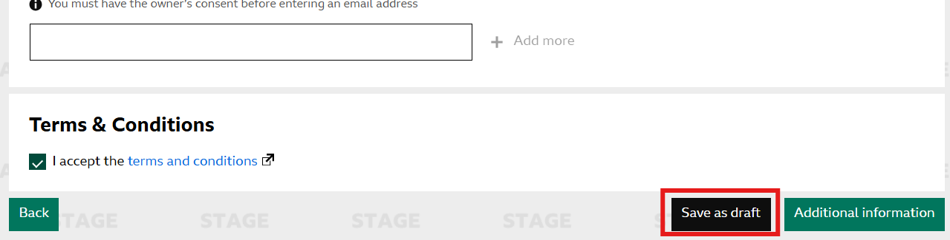

You can reopen your proposal by going to into your proposal list by selecting ‘View all proposals’

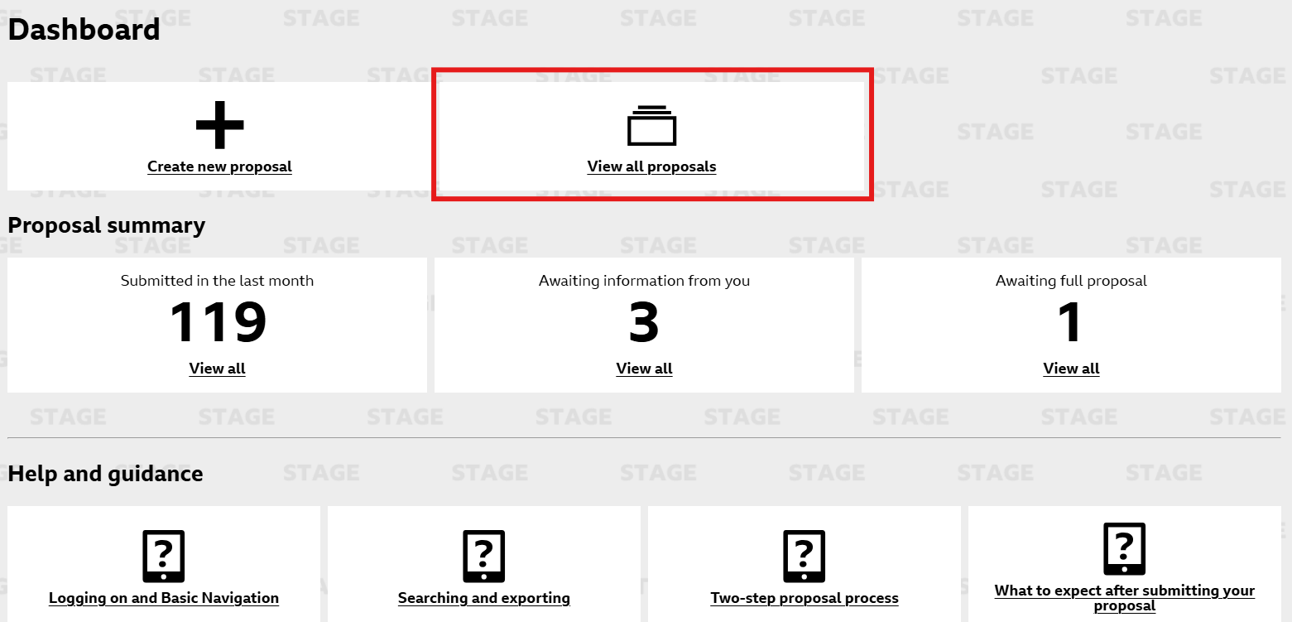

To find the proposal, you can either amend your filters to the correct criteria (Status: Draft, created by me) or you can search for the title.

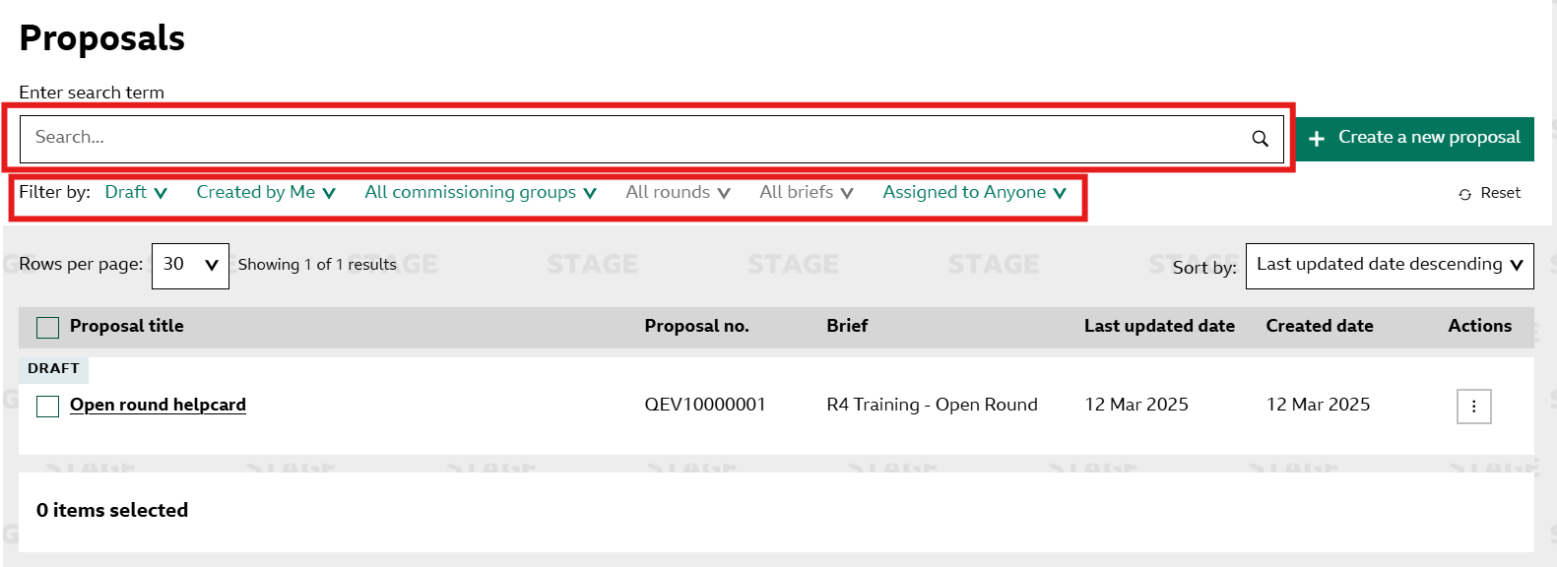

To resume your proposal, select the title of the proposal, this will open it up in a side-by-side view.

Click on the 3 dots in the top right of your proposal and select ‘Edit’

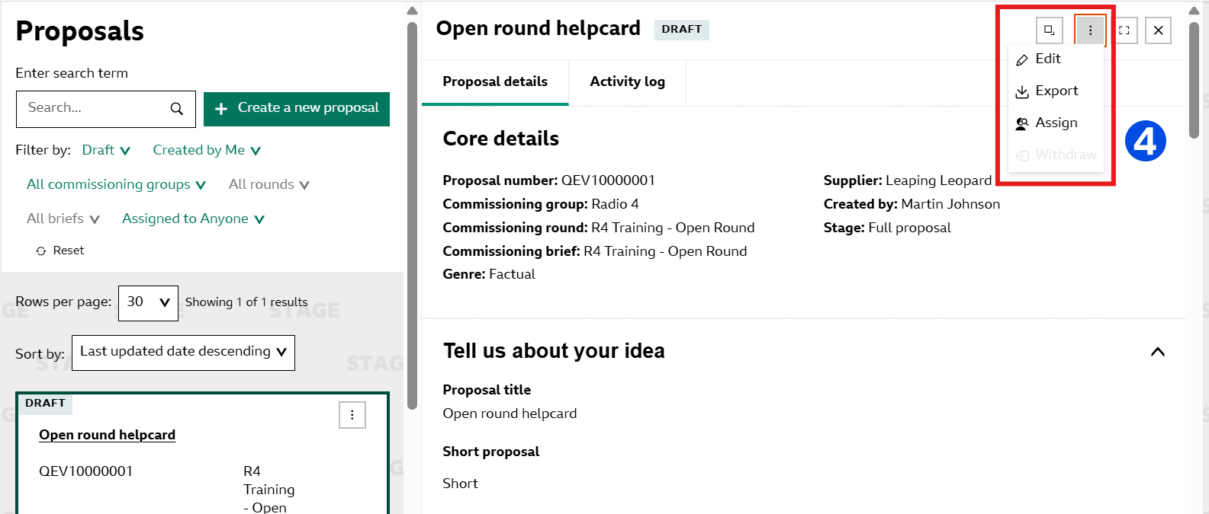

You can now continue to edit and submit your proposal.

Additional Information

In the additional information section, you can upload your supporting documents. The system will only allow you to upload PDF documents.

To upload your document, select the text ‘Choose a file for upload’

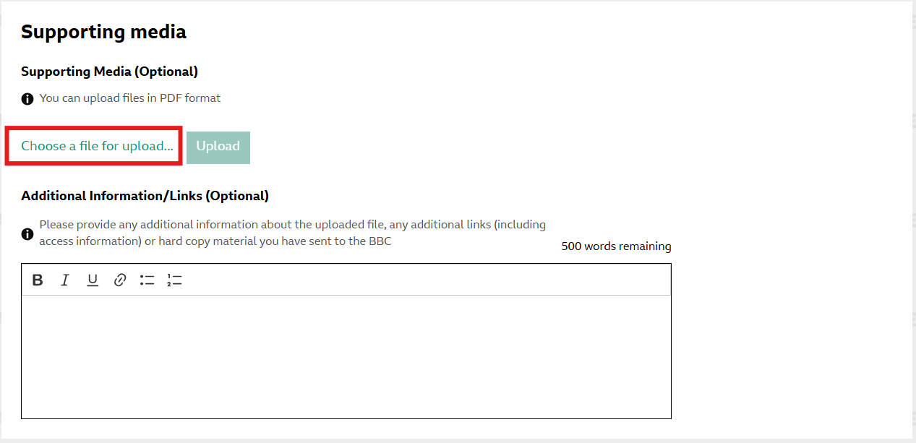

This will open your file explorer where you can select the document you wish to attach to your proposal.

Once you have selected this document, you will then need to select the green button that says ‘Upload’

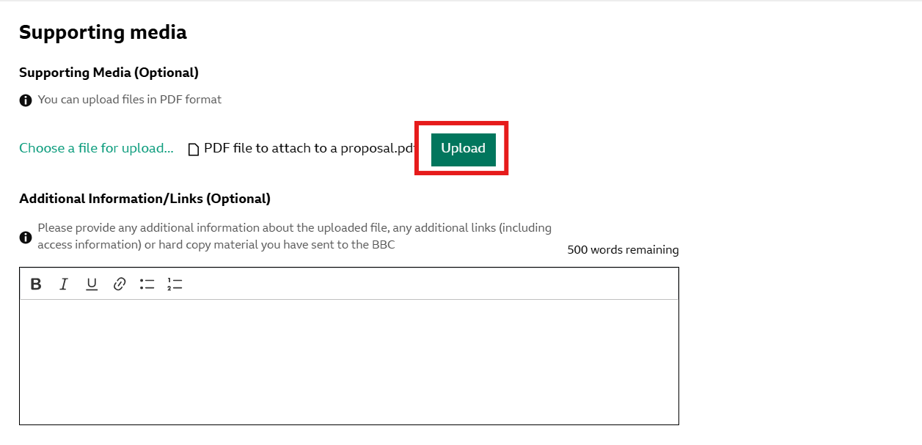

The page will then indicate that the file has been uploaded. You will then have the option to upload further documents to your proposal.

You also have a free text field with a word limit of 500 words. Here you can provide further information regarding your attached document as well as any additional links. Please ensure to include access information if your documents are protected. You can also document and hard copy material that you have sent in.

Once you have completed these sections, you can then ‘Review’ your proposal.

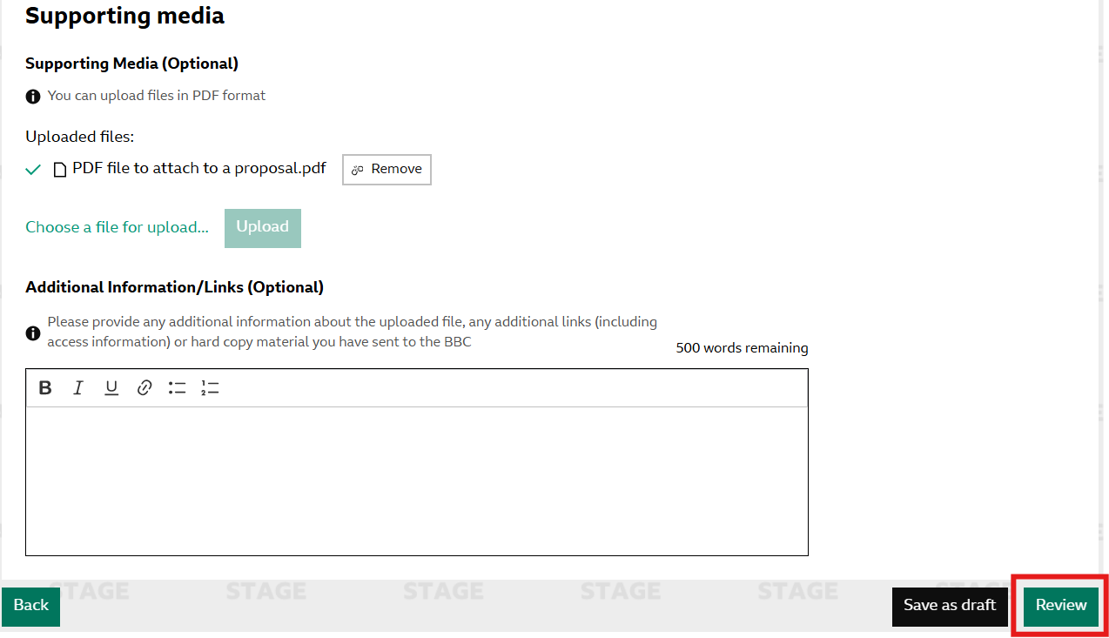

Review & Submit

The review page shows you your completed proposal. If you need to amend any of the information in your proposal whilst reviewing it, you can do so by selecting the ‘Edit Section’ buttons to the right of each section.

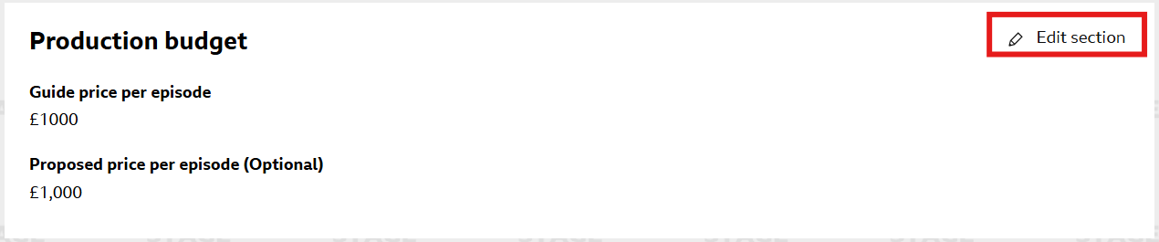

Once you are happy with your proposal, you can ‘Submit’ by selecting the green submit button and the bottom of the page.

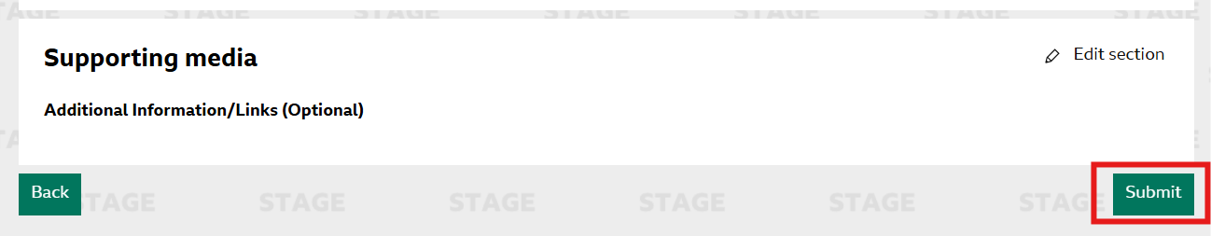

You will receive the below pop up to indicate your proposal has successfully been submitted.

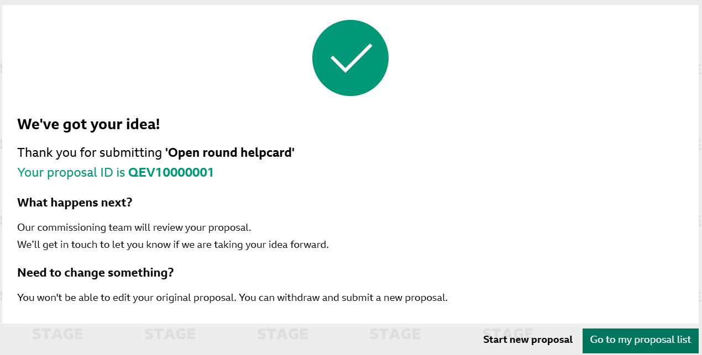

Proposal Form - First stage of a two-step proposal

Overview of the process

In a ‘Two step’ proposal round, you will only be required to submit a short proposal. This is then reviewed in the first stage by the commissioning team, if your proposal is successful, you will then receive your proposal back to then complete your ‘Full Proposal’

Within the first stage you will be required to complete the following stages.

Tell us about your idea
In this section, you will need to add in your Proposal title and the short proposal. The word limit for your short proposal is maxed at 500 words. However, please ensure to refer to your commissioning brief to ensure the word count is not lower that the 500 limit that PiCoS allows.

Contributors

In the next section, please add in the contributors of your programme. The only field that is mandatory is the ‘Producer’ field. All other contributor fields are optional.

You can add additional contributors of the same field by clicking the ‘Add more’ button to the right of the desired field.

About your proposal

The below section is asking for specific information regarding your proposal. All the below fields are mandatory.

Diversity and Inclusion

The next section of your proposal form is all about the diversity and inclusion information. This is separated into three categories, Company Leadership, Production Leadership and Landmark Portrayal.

If you select ‘Yes’ to Landmark Portrayal you will be given a text field to explain for your Proposal meets these criteria. This field has a 250-word count limit.

Production Budget & Notifications

In the Production Budget section of the form, you will see the guide price that has been outlined by the commissioning team. You can then enter your proposed price per episode. This field is optional and can be added by the commissioning team later.

In the notification section, this shows you who will receive the notifications for your proposal. This is defaulted to send notifications to the creator of the proposal. You add additional people if you wish to notify others regarding this proposal, to do this, add their email address in the box provided.

You will then need to tick the Terms and Conditions before proceeding to ‘Additional Information’

Save as draft

Once you have completed the first page of your proposal, you can save this and come back to it later. At the bottom of the page, you will see a black button ‘Save as draft’

You can reopen your proposal by going to into your proposal list by selecting ‘View all proposals’

To find the proposal, you can either amend your filters to the correct criteria (Status: Draft, created by me) or you can search for the title.

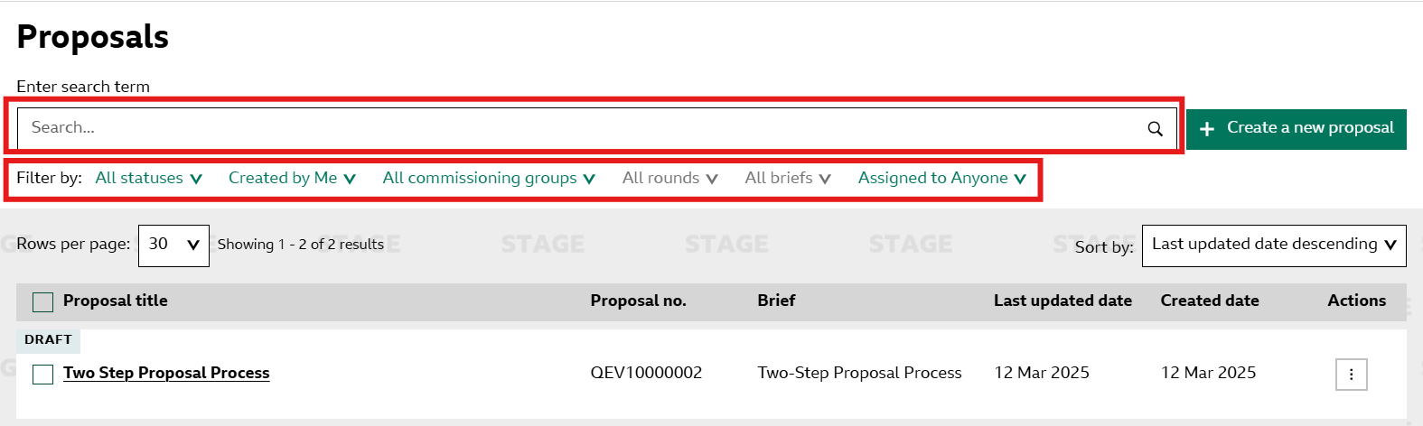

To resume your proposal, select the title of the proposal, this will open it up in a side-by-side view.

Click on the 3 dots in the top right of your proposal and select ‘Edit’

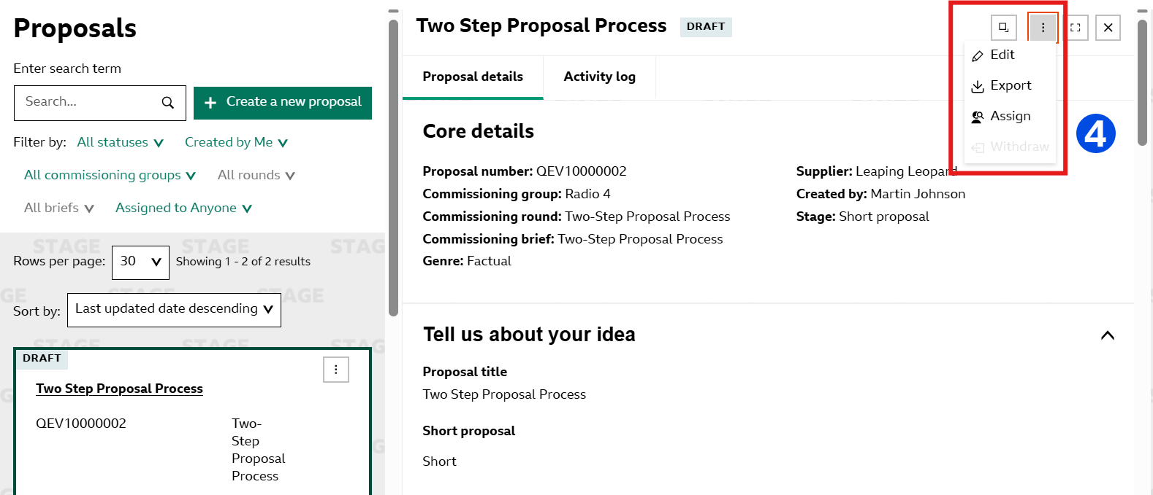

You can now continue to edit and submit your proposal.

Additional Information

In the additional information section, you can upload your supporting documents. The system will only allow you to upload PDF documents.

To upload your document, select the text ‘Choose a file for upload’

This will open your file explorer where you can select the document you wish to attach to your proposal.

Once you have selected this document, you will then need to select the green button that says ‘Upload’

The page will then indicate that the file has been uploaded. You will then have the option to upload further documents to your proposal.

You also have a free text field with a word limit of 500 words. Here you can provide further information regarding your attached document as well as any additional links. Please ensure to include access information if your documents are protected. You can also document and hard copy material that you have sent in.

Once you have completed these sections, you can then ‘Review’ your proposal.

Review & Submit

The review page shows you your completed proposal. If you need to amend any of the information in your proposal whilst reviewing it, you can do so by selecting the ‘Edit Section’ buttons to the right of each section.

Once you are happy with your proposal, you can ‘Submit’ by selecting the green submit button and the bottom of the page.

You will receive the below pop up to indicate your proposal has successfully been submitted.

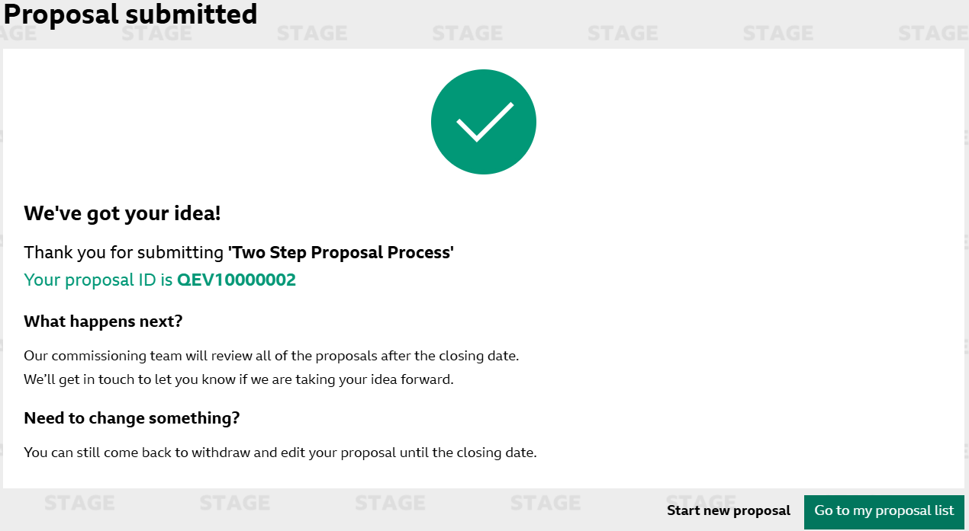

Proposal Form – Second stage of a two-step proposal

Knowing your proposal has progressed

If your proposal has been successful in the first stage of the commissioning round and you have been asked to submit a ‘Full Proposal’, you will receive an email notifying you of this status change and your proposal will be sent back to you to re-submit this information.
This proposal will show up on your dashboard under ‘Awaiting Full Proposal’

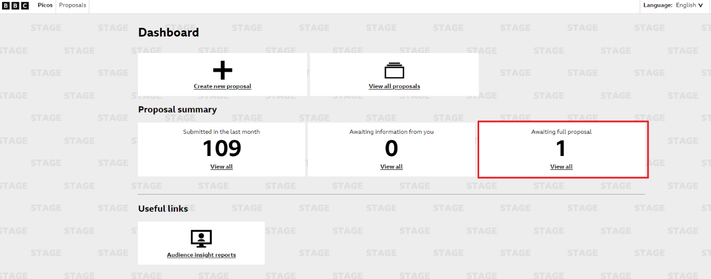

Navigating to your proposal

When you click on the ‘View all’ link within ‘Awaiting full proposal’ on the dashboard, you will be taken to the proposals page where you will see all of your proposals that require a ‘Full Proposal’. From here, you can click into the specific proposal you wish to submit a ‘Full Proposal’ for.
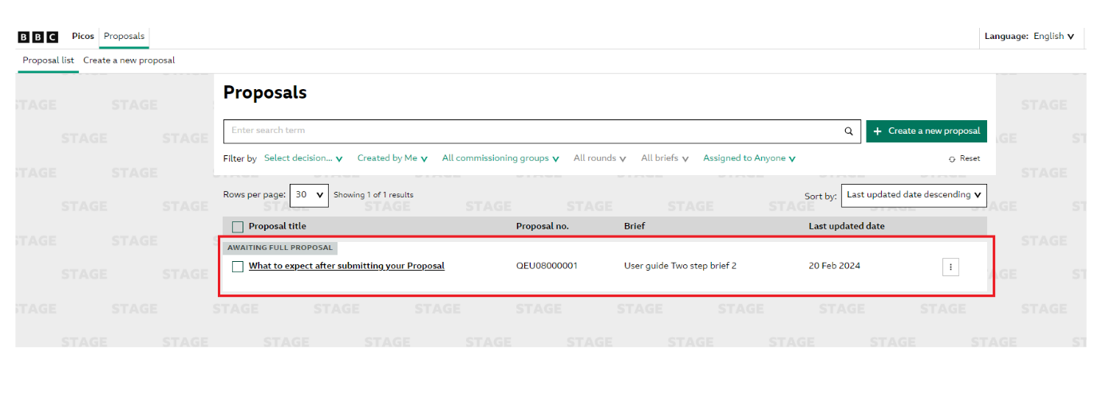

Adding your Full Proposal

Once you are in the specific proposal, you can scroll to the bottom of your screen where you will see an ‘Edit’ button. If you click on this you will then be able to start re-submitting your proposal to include the ‘Full Proposal’.

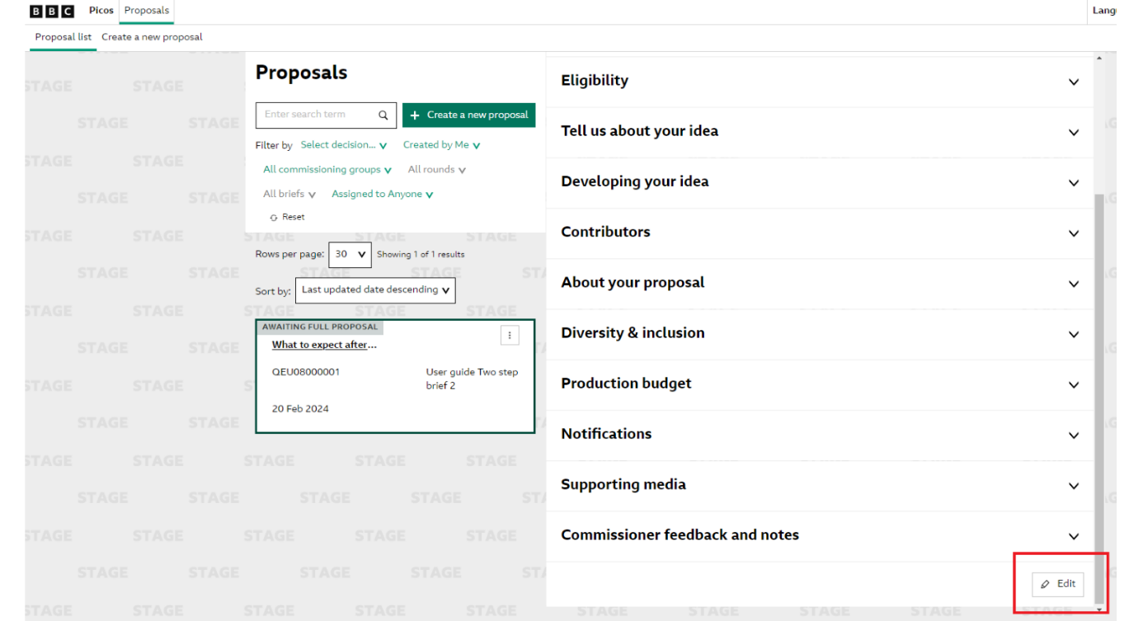
Once you have clicked ‘Edit’ you will see the below pop-up where you can see all relevant information of your proposal and a confirmation it has progressed to the second stage.
Click on ‘Start’ to submit your proposal.
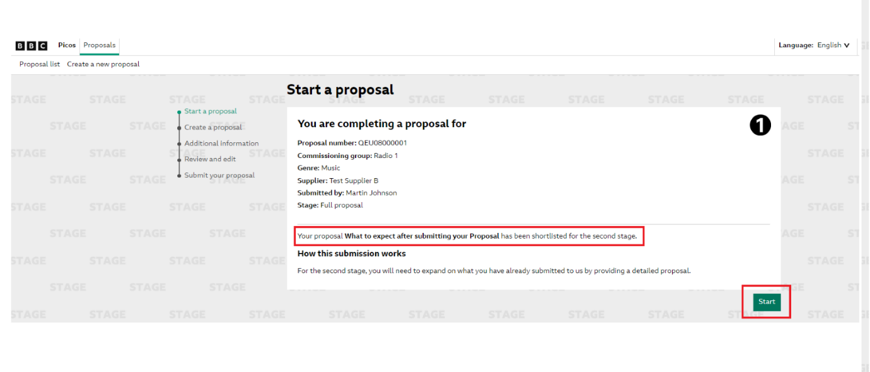
You will now be in your proposal where you can fill in the ‘Developing your idea’ section. This is where you will input your ‘Full Proposal’. Please note that you can also amend other fields at this stage such as ‘contributors’, ‘About your Proposal’ and ‘Diversity & Inclusion’.
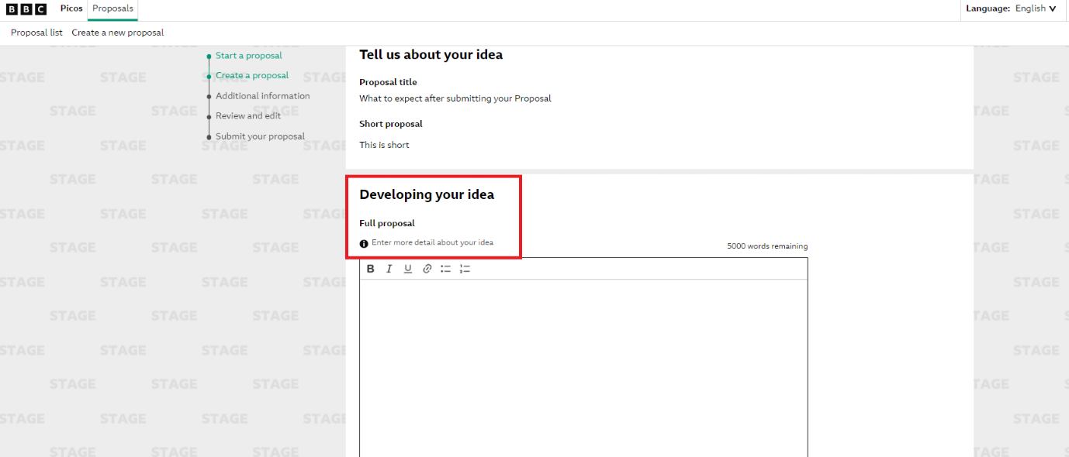

Adding Additional Information
Once you have completed your full proposal and amended any other fields as required, you can then scroll to the bottom of the page, accept the T&Cs and click on the ‘Additional Information’ button.

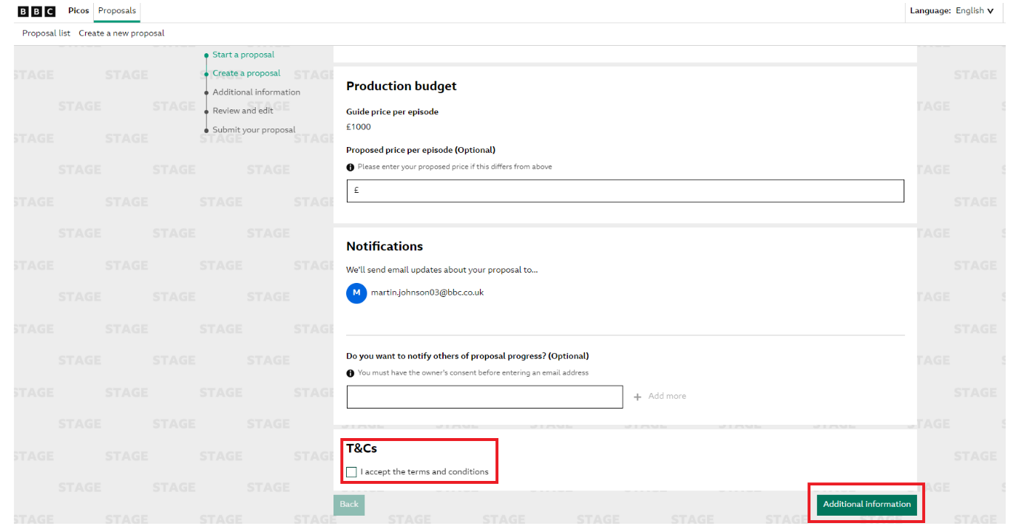
This will take you to the ‘Additional Information’ page. On this page, you can add any supporting media to your document (for example, scripts, images and web links to support your proposal).

Review & Submit
Once completed you can click the ‘Review’ button. This will bring up a summary of your full proposal before you go ahead and submit.
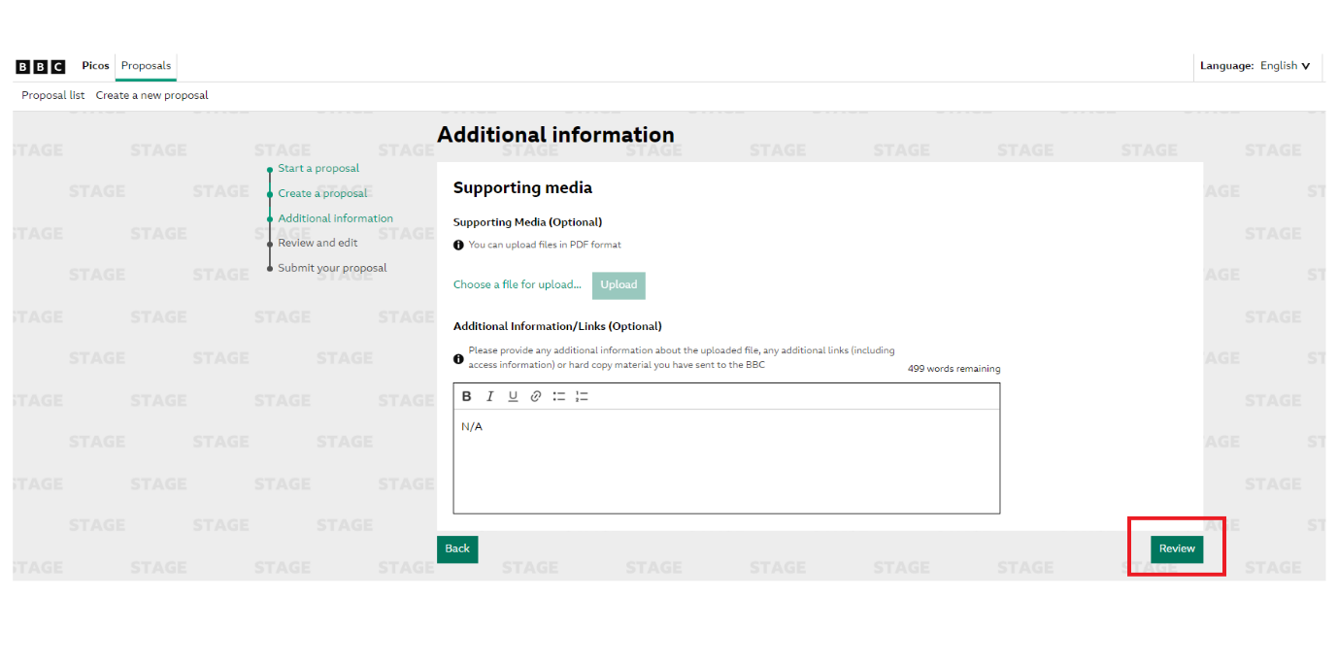
Once you have reviewed your proposal you can scroll to the bottom of the page and click the ‘Submit’ button.

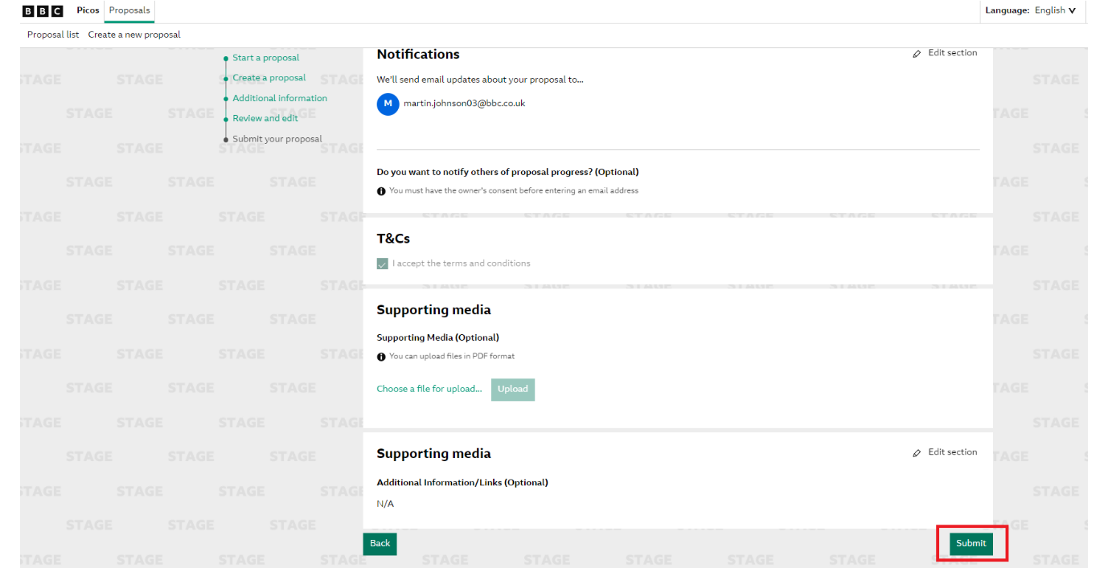

You will receive the below pop up to show your full proposal has been submitted

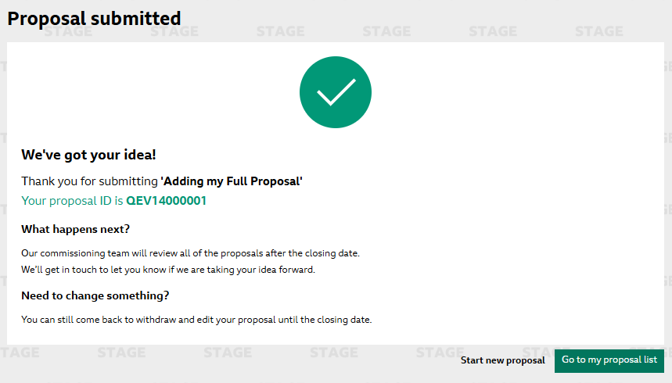

Once you have submitted your Proposal the status will change to ‘Shortlisted’ this is another indicator that you have successfully submitted your full proposal.

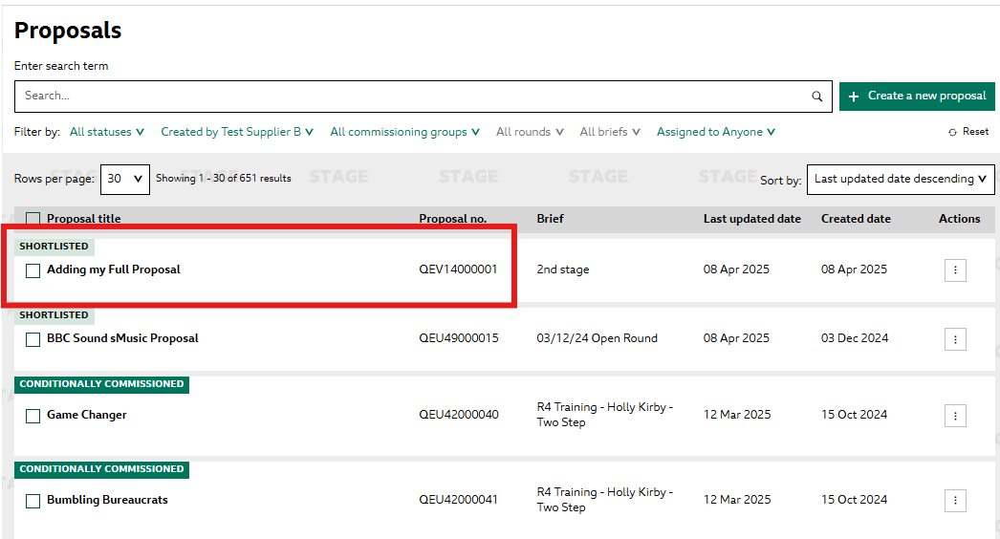

Internal Only - Submitting to Department
For BBC Internal Audio production departments there is a two-level submission process. This allows users to submit proposals to their department where they can then be reviewed by a super user who can then submit these proposals onto the Network.

Once you have completed the above sections in this guide regarding creating your proposal, you may get to the Review & submit section and be presented with the below ‘Submit to department’ button.

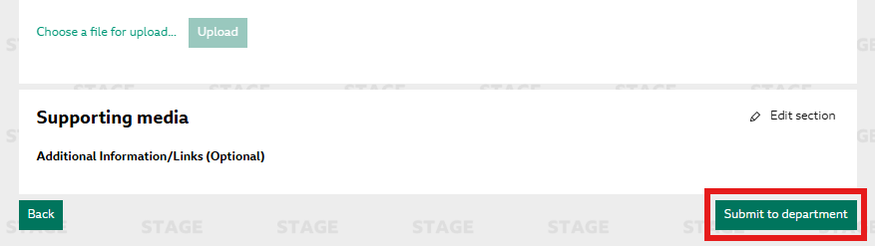

Once you have pressed the above button, you will get a confirmation that you have submitted your proposal to department level.

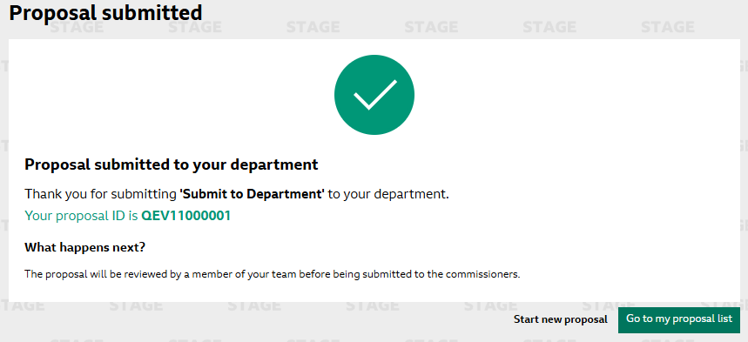

You will also be able to see this proposal in your ‘Proposal List’ page. Please note that the status of this proposal will be shown as ‘Draft’ until it has been submitted to Network.

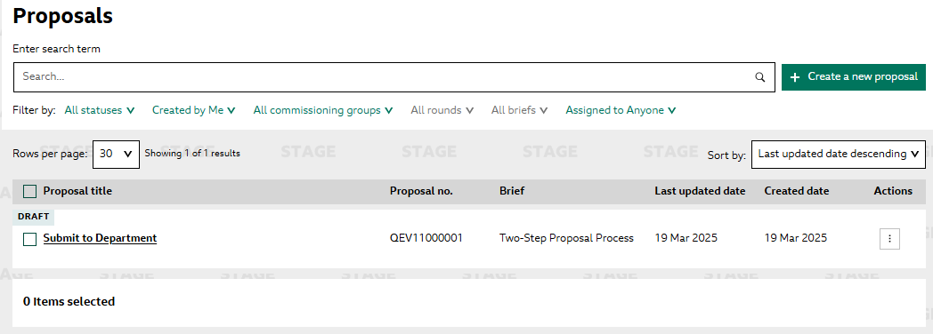

Now that your proposal has been submitted to your department, this can then be reviewed by a user in your department that has the ‘Submit to Network’ functionality applied to their account. You will receive a notification once they have submitted this proposal.

Internal Only – Reviewing and Submitting to Network

For BBC Internal Audio production departments there is a two-level submission process. This allows users to submit proposals to their department where they can then be reviewed by a super user who can then submit these proposals onto the Network.

Once a user in your department has submitted their proposal, you will be able to review this and then submit this onto the network into their commissioning round.

To review these proposals please go to ‘View all proposals’
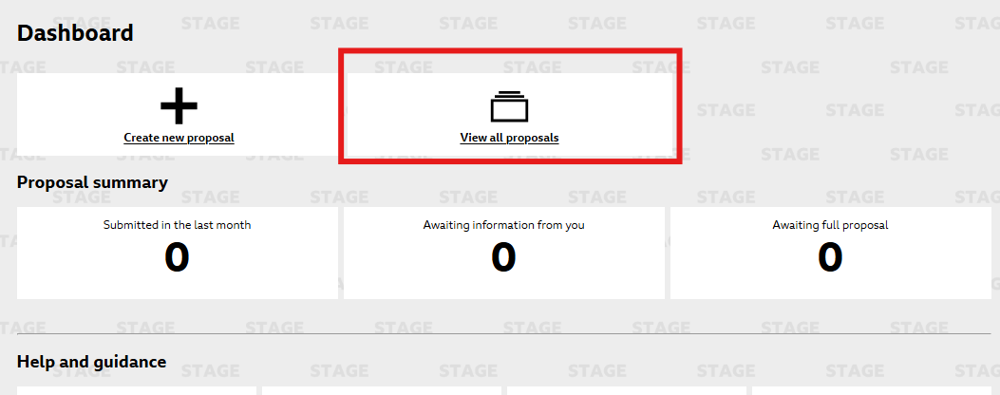

Once you have opened your ‘Proposal List Page’ this will default to proposals that have been created by yourself, to view the proposals submitted by your department, please amend the filters to ‘Created by ‘department name’’.

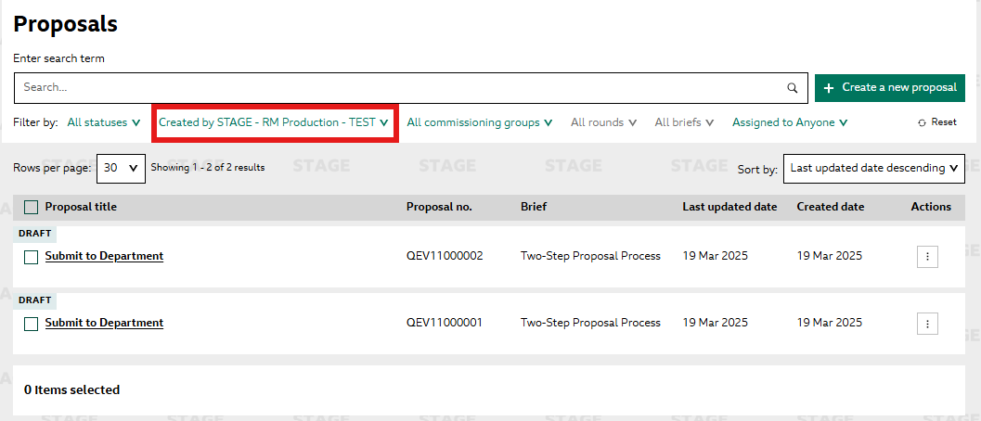
The Proposals that have been submitted to department will display with status of ‘Draft’ (as shown in the image above)

Click on the proposal you wish to review and submit to network

To review and submit this proposal, open the proposal and select ‘Edit’

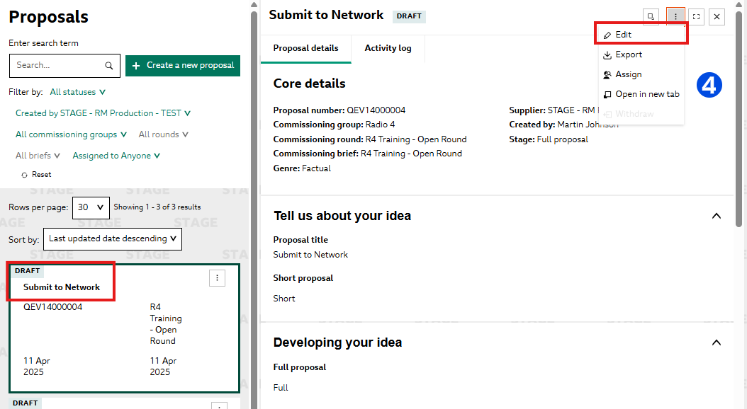
This will open the proposal form where it can be edited. Once you are happy with the proposal and have made all of the required changes and you have ‘Reviewed’ your proposal.

At the bottom of the page there will be a ‘Submit’ button. Click this to submit your proposal to the network.
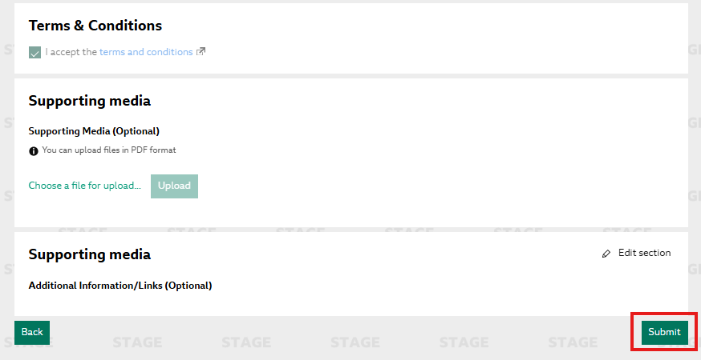
When you press submit a pop up will appear to confirm you have submitted your proposal.

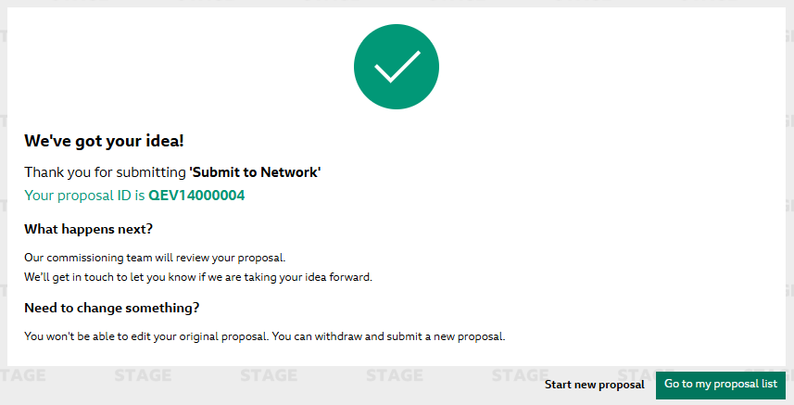
You will also see the status of your proposal in your ‘Proposal list’ page change from ‘Draft’ to ‘No Decision’. If this is part of the second stage you would see this change from ‘Awaiting full proposal’ to ‘Shortlisted’

