Logging on and basic navigation (Supplier)

Supported browsers
Make sure you are using one of the following supported browsers for BBC PiCoS
- Google Chrome
- Firefox
- Safari
- Microsoft Edge
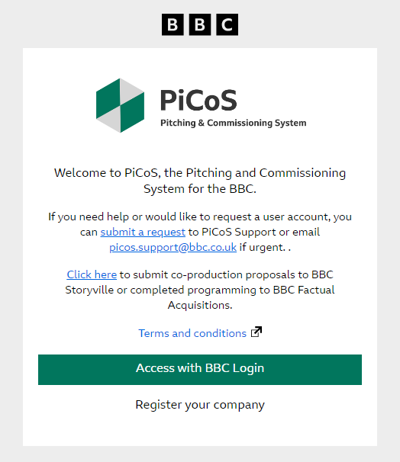

Logging on to PiCoS
From the PiCoS landing page you will be able to log in to your registered PiCoS account by clicking ‘Access with BBC Login’.
For BBC users, you will use SSO (Single Sign On) to log in. If you are having trouble with this you can visit the BBC Login FAQs page
For external users, a BBC login invite will be sent to the email used to register for a PiCoS account. If you are having difficulties with this, please contact picos.support@bbc.co.uk.
Your account will be locked if an incorrect password is entered six times. This is an intentional security feature designed to protect accounts.
If you have forgotten your password you can reset it. Please do not send new registration applications for forgotten/lost passwords, as these will be rejected.

The PiCoS Dashboard
Once you have logged in, your dashboard should look like the screenshot below. On the top row of the dashboard you can navigate to ‘Create a new proposal’ or ‘View all proposals’.
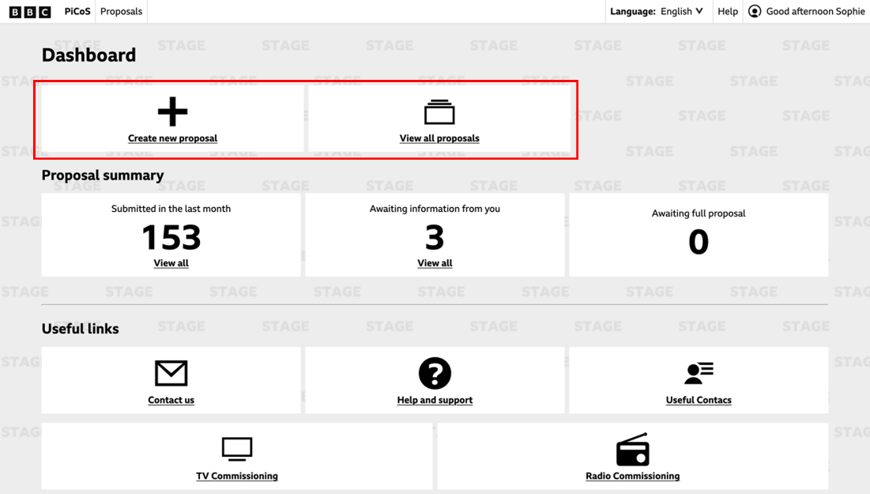
Clicking on ‘Create new proposal’ will take you to either the ‘Audio proposal opportunities’ (above left image) or ‘TV proposal opportunities’ (above right image). In most cases, you will only see either the Audio or TV tab, depending on your production company’s proposal area. On rare occasions, you may have tabs to propose for both Audio and TV at the top of your screen.
From here you will be able to select a network and continue with your proposal.
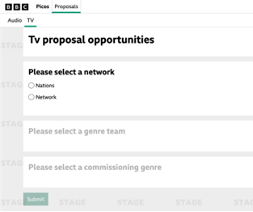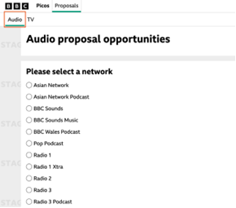
By clicking ‘View all proposals’ on the dashboard, you will be taken to the proposals list, which will initially show all your created proposals. By changing the ‘Created by Me’ filter, you can select to view all proposals by your production company. You can also filter by proposal status, commissioning group, rounds and briefs, and who it is assigned to.
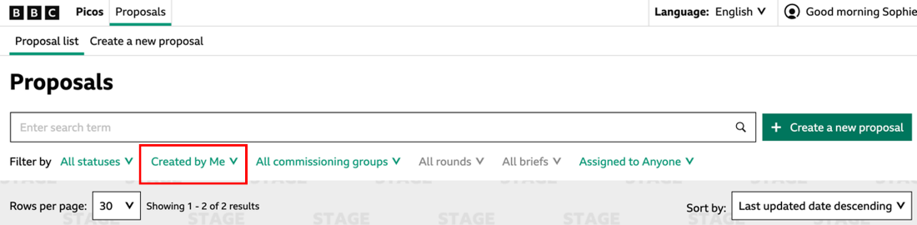
From the ‘Proposal list’ screen, you can also navigate to the ‘Create a new proposal’ screen by clicking the tab at the top, or the green button to the right of the search bar.
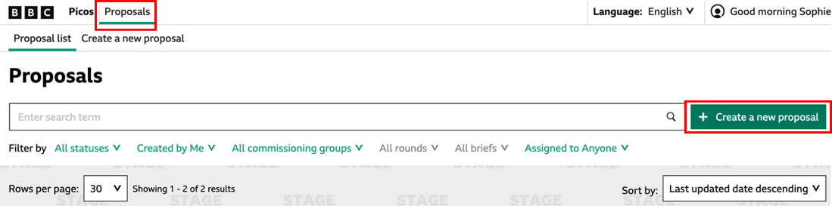
On the second row of the dashboard, titled ‘Proposal summary’, you can view the information on your recent proposals. This includes the number you have submitted in the last month, the number of proposals that require further information from you, and the number that are awaiting full proposals.
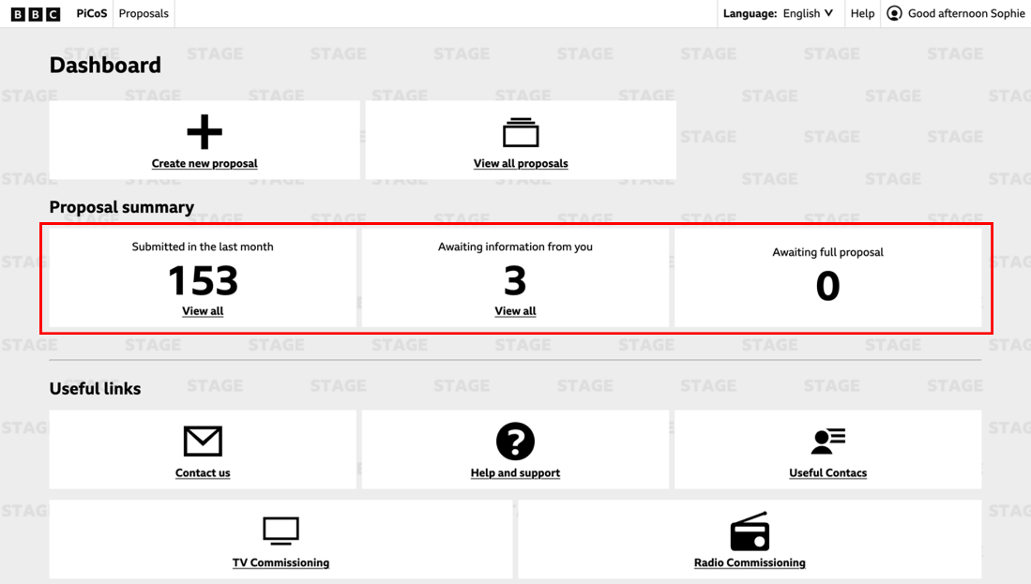
If you scroll down, you can see the full ‘Useful Links’ section. Clicking ‘Contact us’ will take you to a form to contact our Support team. ‘Help and Support’ takes you to the PiCoS academy page and ‘Useful Contacts’ shows you information for Delivery and Business staff.
There are several links for commissioning areas, with more information depending on where you are pitching to. ‘Audience Insight Reports’ provide useful information of audience demographics.

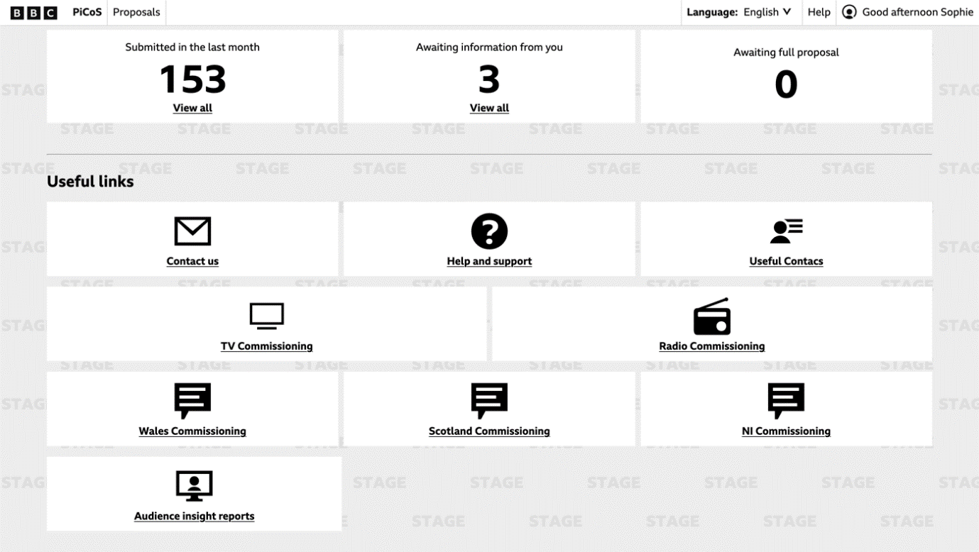
Clicking the ‘Help’ button at the top of the screen will take you to a form that puts you in contact with our support team, should you have any further questions.
