Two Step Proposal Process

Knowing your proposal has progressed
If your proposal has been successful in the first stage of the commissioning round and you have been asked to submit a ‘Full Proposal’, you will receive an email notifying you of this status change and your proposal will be sent back to you to re-submit this information.
This proposal will show up on your dashboard under ‘Awaiting Full Proposal’
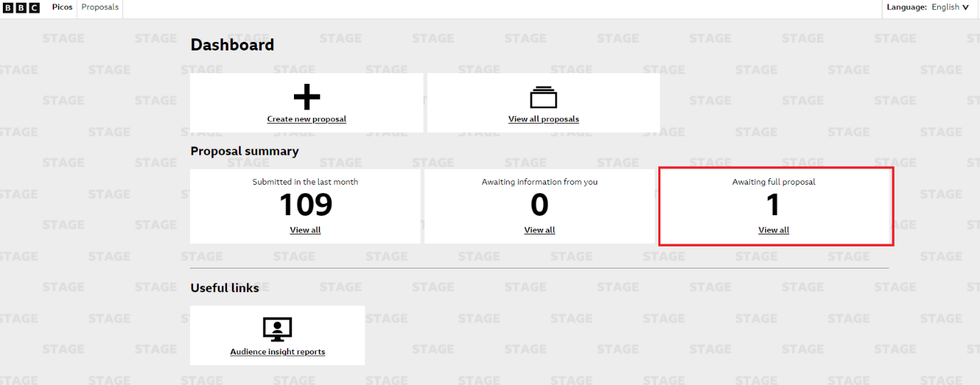

Navigating to your proposal
When you click on the ‘View all’ link within ‘Awaiting full proposal’ on the dashboard, you will be taken to the proposals page where you will see all of your proposals that require a ‘Full Proposal’. From here, you can click into the specific proposal you wish to submit a ‘Full Proposal’ for.
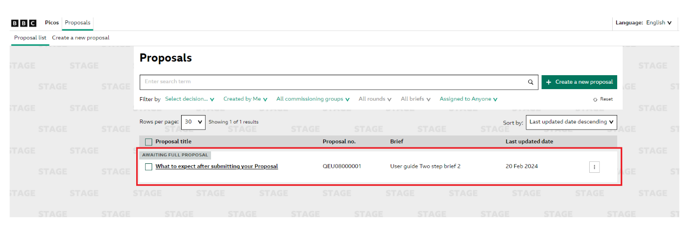

Adding your Full Proposal
Once you are in the specific proposal, you can scroll to the bottom of your screen where you will see an ‘Edit’ button. If you click on this you will then be able to start re-submitting your proposal to include the ‘Full Proposal’.
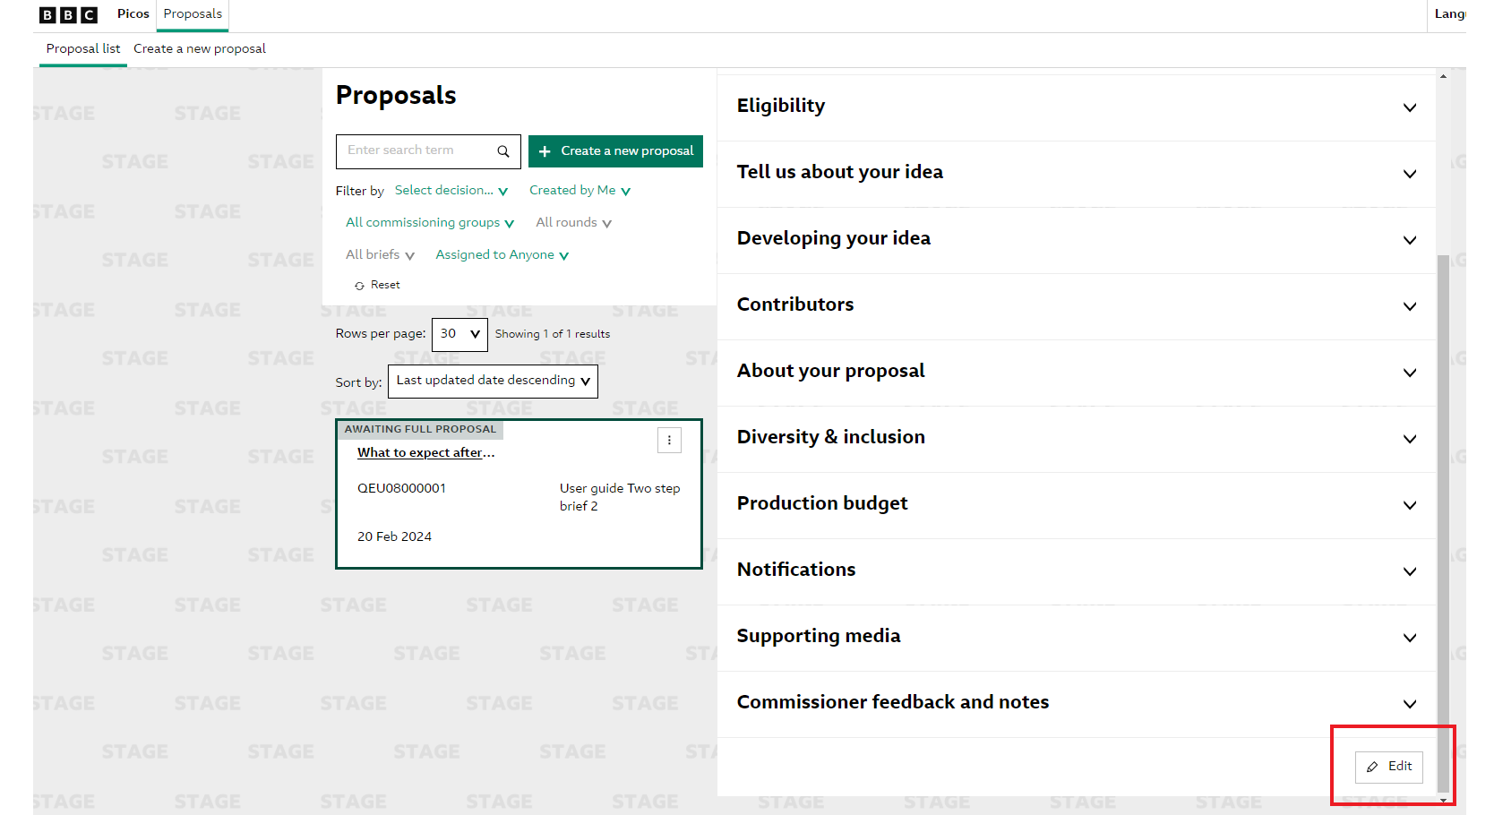
Once you have clicked ‘Edit’ you will see the below pop-up where you can see all relevant information of your proposal and a confirmation it has progressed to the second stage.
Click on ‘Start’ to submit your proposal.
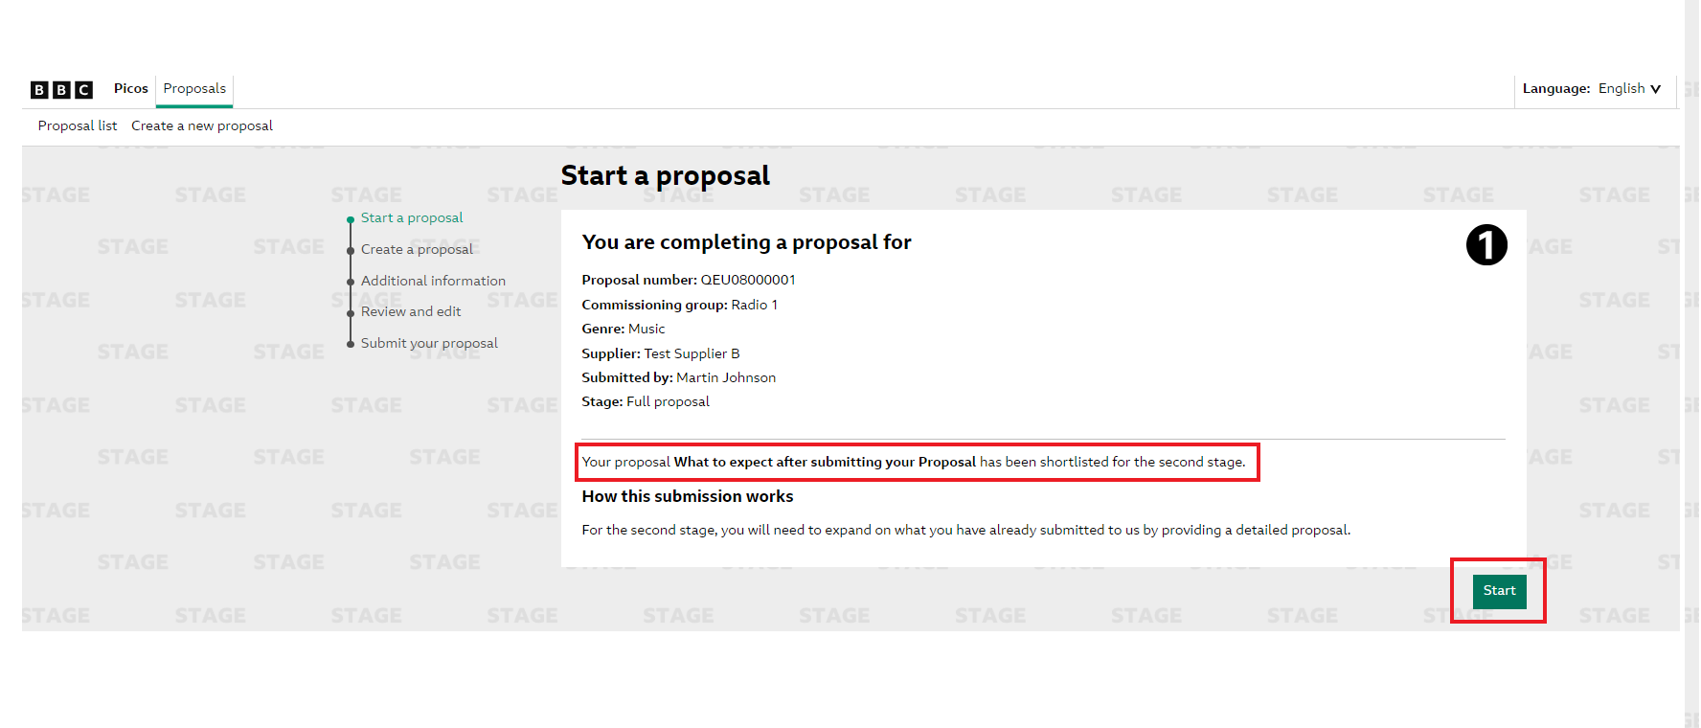
You will now be in your proposal where you can fill in the ‘Developing your idea’ section. This is where you will input your ‘Full Proposal’. Please note that you can also amend other fields at this stage such as ‘contributors’, ‘About your Proposal’ and ‘Diversity & Inclusion’.
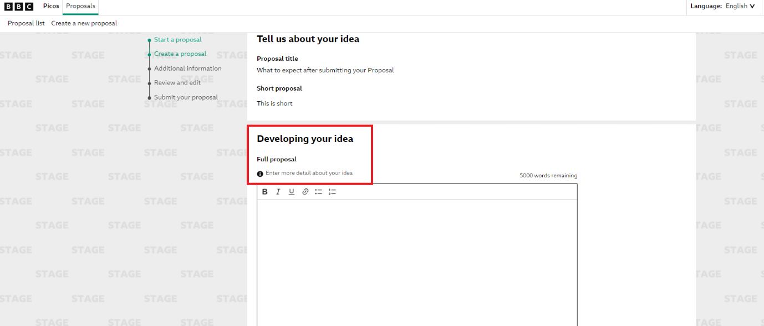

Adding Additional Information
Once you have completed your full proposal and amended any other fields as required, you can then scroll to the bottom of the page, accept the T&Cs and click on the ‘Additional Information’ button.
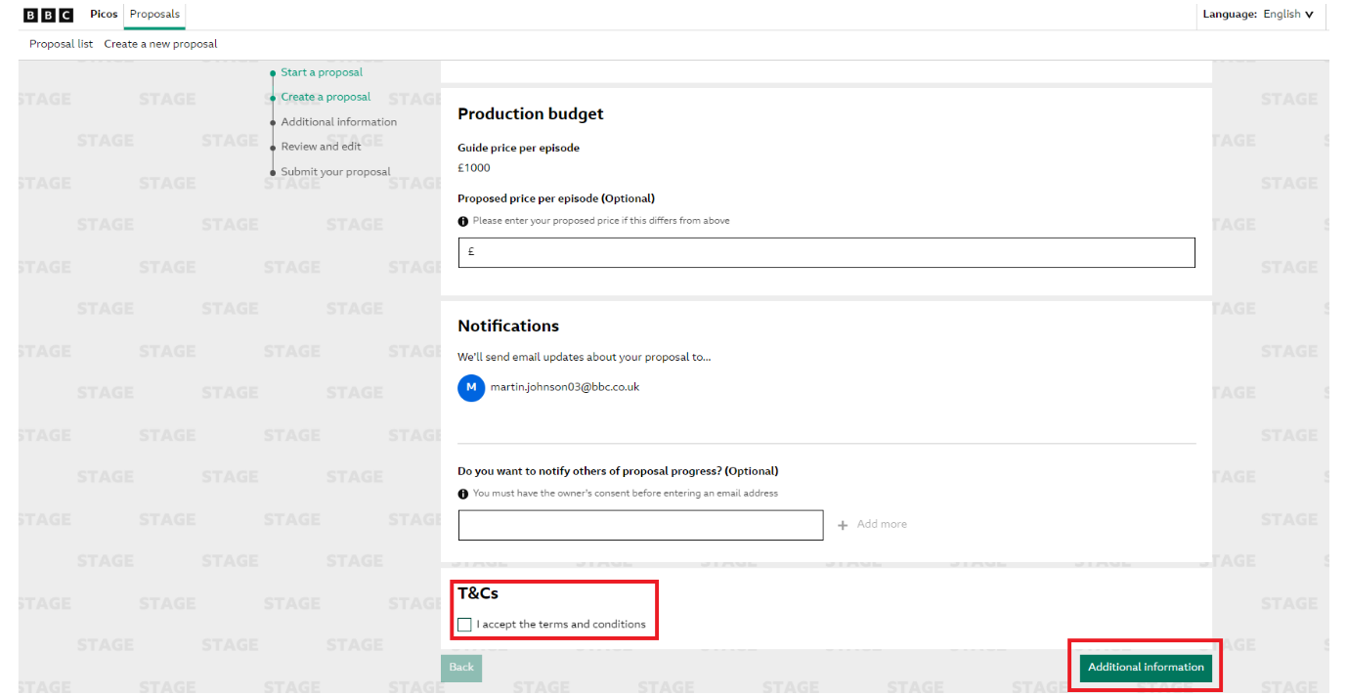
This will take you to the ‘Additional Information’ page. On this page, you can add any supporting media to your document (for example; scripts, images and web links to support your proposal).

Review your Full Proposal
Once completed you can click the ‘Review’ button. This will bring up a summary of your full proposal before you go ahead and submit.
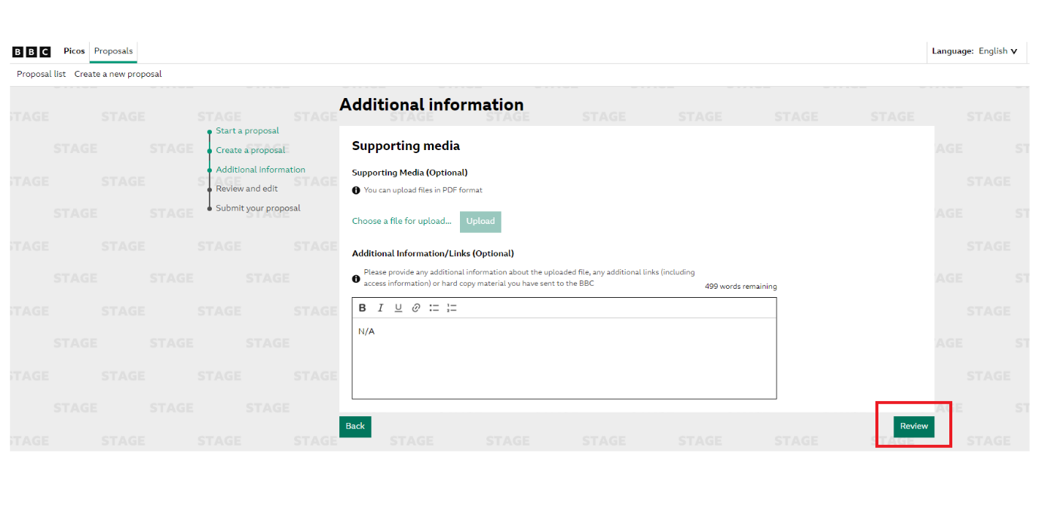

Submit your Full Proposal
Once you have reviewed your proposal you can scroll to the bottom of the page and click the ‘Submit’ button.
This will then generate a pop up to confirm you have submitted your proposal. You will also be notified by email that your proposal has been submitted.
